Catch Game Document

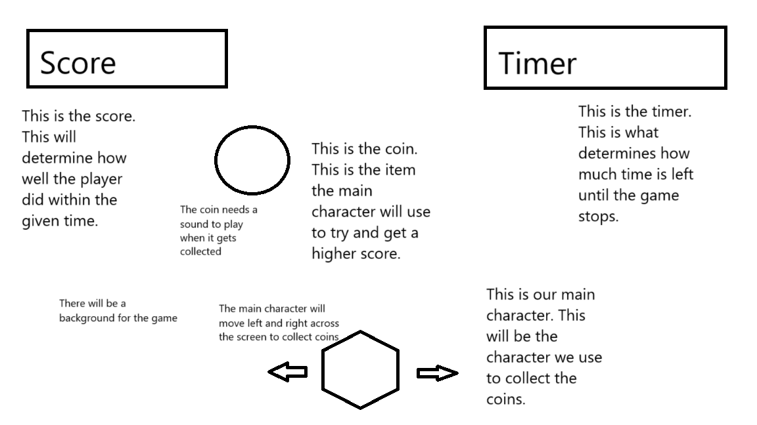
In this image above it shows many different things the game will utilize when in the game screen. The player on the bottom of the screen will move left and right to collect coins that I represented with the circle. These coins will fall from the top of the screen and will be used to give the player a higher score. This score will be saved in the top left of the screen, and this will keep the data so it can be displayed on the title screen. In the top right of the screen will be the timer. This timer option will tell the game when the player should be sent back to the title screen. The timer also helps the player know how much time they have left until they are sent back to the title screen.
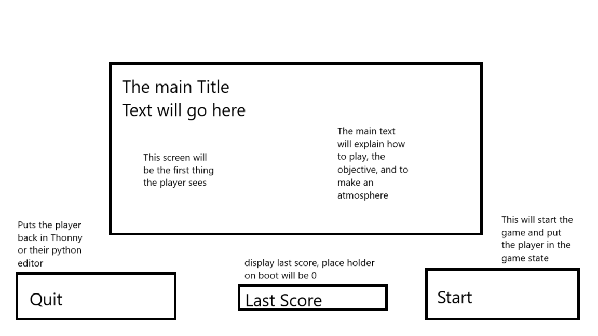
This is the mockup of the title screen, and this is the first thing the player will see when booting up the game. This screen will have the info on how to play the game as well as the main ways to start the game. The title screen will also hold the last recorded score with the starting info. This screen will be used mainly to try and create an atmosphere for the player to try and build a world for the player to experience.

Sprites
The Sprites I want to use for this game would be a turtle in an abstract area trying to catch leaf’s falling from the sky. To recreate that idea I decided to use a turtle sprite as well as a leaf image for the 2 main sprites. The size of the turtle I decided will be 65 pixels by 30 pixels. This way I can keep the proportions of the turtle while also making sure the turtle doesn’t look super weird. For the leaf I went with 25 pixels by 25 pixels. The image I used helps keep this size looking normal while also making the leaf small. For this game both of these sprites go under the SuperSprite context. For the sprites themselves, the leaf spawns at the top of the screen in random locations once the game starts. These leaf’s will move at random speeds to try and reach the ground, these will all be controlled by the computer. Once they reach the bottom or touch the turtle they will respawn and then respawn at the top. The turtle spawns in the middle of the screen once the play button is clicked, the player then controls where it moves on the screen. The turtle will move 3 pixels per frame to represent the slow-moving creature. The turtle also has the capability to wrap around the screen when playing to move from one side to another.

UI
I would explain what’s going on in the game, and how the player will control the character. In the game, I will put:
"You are a Turtle!",
"Move with the arrow keys",
"Catch as many Leaf's as you can!",
"This game is timed, so be aware",
"Have Fun!"
This will help the player understand the objective, how to play, and the basic idea of what will happen once they press the play button. During the game the player will encounter the score, timer, coins, character, and background. These assets will be crucial to the player as they will help them understand how to get the highest score possible. For the Title screen this will show the player their last score, the title screen text on how to play, as well as the quit and start buttons to start and quit the game. The player’s last score will take the number from the game the player just played and display that on the title screen. To keep the code simple, when booting the game, it will display a 0. The player should expect to see at most 10 leaf’s falling from the sky towards the ground to collect. The player will also see a turtle that can move left and right to try and collect the leaf’s. The timer and score will go in the top corners of the screen when playing to stay out of the players way. On the title screen the start and quit will be in the bottom corners, the main text will be in the middle of the screen, and the last score will be in the middle of the start and quit options.

Game State
There will be 2 different game states, the title screen and the game play. To transfer between the se 2 different states, we will utilize the start button and the timer. On the title screen the start button will move the user to the game screen. From the game screen, the player will have to wait 25 seconds to move back to the title screen. For info like the last score, that will be moved from both states using a class. This class will help keep the past score, and then we can move that score back to the title screen. The game will end once the timer hits 0, at that time the game will send you back to the title screen to either play again, or to quit the game.

Sound effects
For this game, I will only be using just one sound effect which will be the sound for when the leaf hits the player. When making the leaf sound effect, I had to make sure that this sound only works when it hits the player, and not whenever it wants. This sound effect will sit best in the game class. It will work best here because it will help keep the sound effect in the game state portion of the game.

Images
For this game there will be a background image, player image, and leaf image that will all be needed to complete the project. The background image I decided to pick was an abstract leaf image. For the player I picked a toon image of a turtle. For the falling leaf’s I decided to pick a small toon leaf. All of these images come from the website openclipart. This website has free to use images which helps keep this project free to use anywhere without the worry of copyright.

Sound
For this project, I used a sound effect to make sure the player would know they touched a leaf. I decided to use a munching sound to represent the turtle eating the leaf. This sound effect came directly from pixabay, pixabay is a free to use sound effects website, which is where I grabbed my sound effect.

